Code Analyzer Application

M SWATI

Introduction

Objective of the project:

- To analyze the source code for various software quality metrics

About the Software
- Code Analyzer is a type of software testing application that reviews, analyzes and reports on the source code structure of a program or software.
- The Code Analyzer GUI is built around the java tree display component, JTree.Projects
are constructed by adding branches to the tree.
- First an Extension set must be selected, and the subsequent folders are branched.
- Files can be excluded from the branch if and when required.

Languages Supported

● | C
● | C++
● | java
● | html
● | Assembly

List of Metrics

- Total Files (For multiple file metrics) : Total number of files included in the directory

- Total Lines : Total number of lines in source file.

- Code Lines : Total number of lines except whitespace lines and comment lines

- Comment Lines : Lines consisting of comments

- Whitespace Lines : a line of source containing no comments or code.

- Average Line Length : Total number of words / Total number of lines

- Code/Comments Ratio : Total lines of code / Comment lines

- Code/Whitespace Ratio : Total lines of code / Whitespace lines

- Code/(Comments + Whitespace) Ratio : Total lines of code / Comment + Whitespace lines
Execution Procedure

1) Select an Extension Set

The Extension Set must be selected before building a Code Set, else we will not be able to save the Code Set or analyze the Code Set. To select an extension set, select "Tools|Extension Sets|Select".

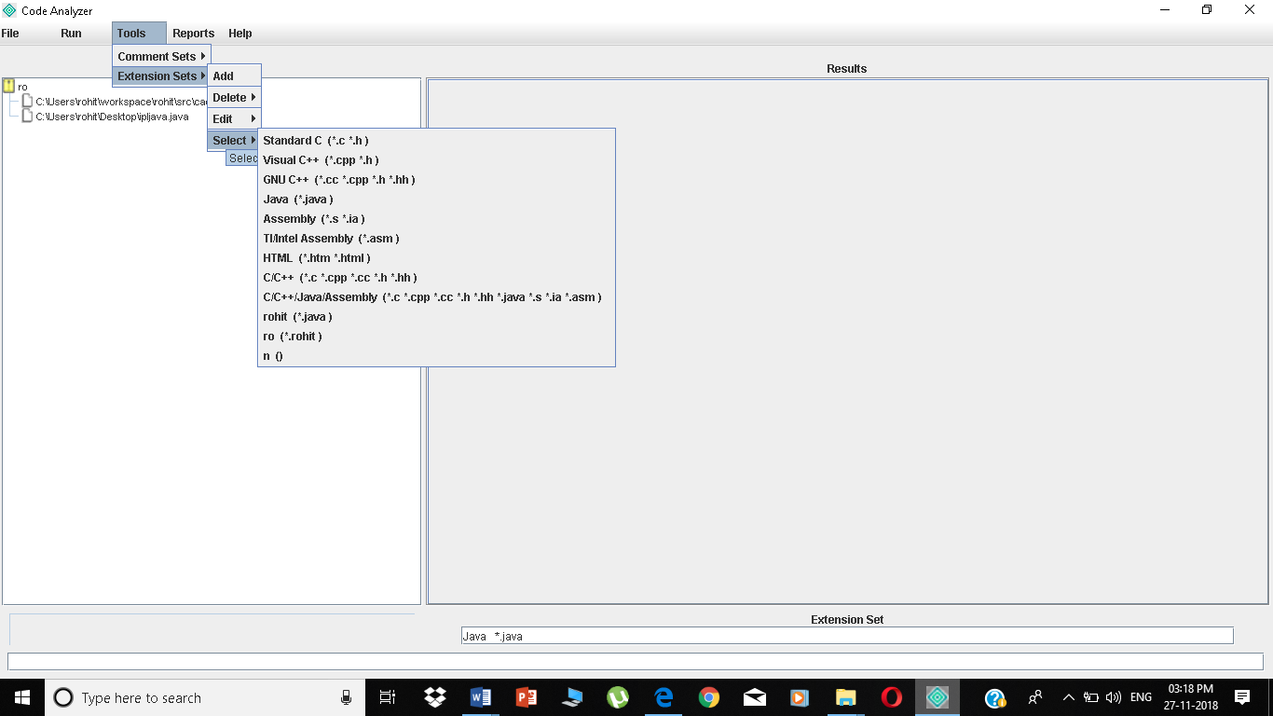

2) Add "Branches" to the Code Set

Right click on the root node and select "Add Branch" from the menu. This will open a File Open dialog from which you can select a directory to add to the Code Set. All files (which match the selected Extension Set) and directories beneath this directory (folder) will be added to the Code Set.

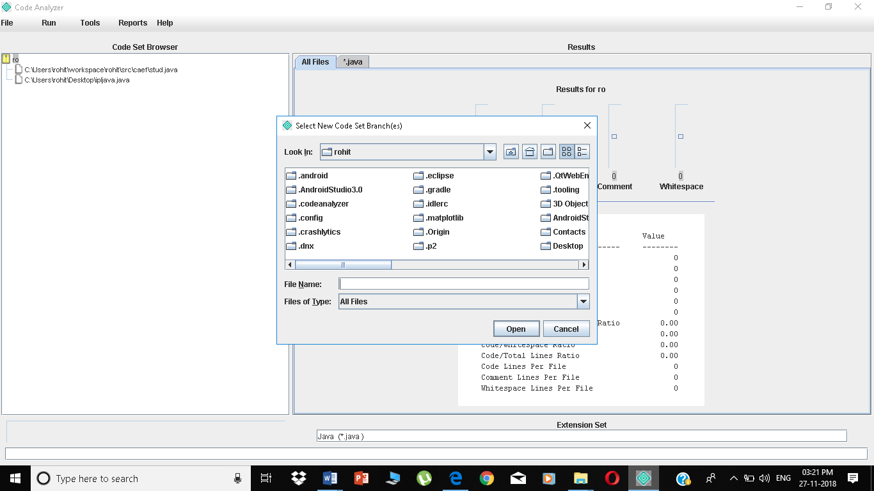

- Exclude Unwanted Files or Folders - To exclude a file or folder from the Code Set, right click the mouse while pointing at the file or folder. Select "Exclude" from the menu. The file or folder will become red in color to signify that it is excluded. If it is a folder, all files and folders beneath it will also be excluded.

Analyzing Code Set

To analyze a Code Set, select "Run|Run". This process may take some time, based on the size of the Code Set. Progress is indicated in the progress bar near the bottom left side of the window. Progress is also indicated as the included files and folders will turn "green" in the Code Set tree view after they have been analyzed. To stop analysis before it has completed, select "Run|Stop". The Code Set will have all metrics reset to empty or zero-value.

Note:

- A line of source may be both a comment and a code line simultaneously.

- Therefore, the sum (code + comments + whitespace) may often be greater than the total lines metric.

- During analysis, the Code Set tree view will be disabled. Mouse events are ignored until the analysis is complete.

- During analysis, the majority of the menu selections such as "File|Load Code Set" or "Tools|Extension Sets|Select" will result in a warning only in the status display. This is for obvious reasons. Stopping the analysis, creating new Comment or Extension Sets, and Help functions will remain functional.

Analysis Results

Analysis results are available in three forms.

- The results view will display metrics for the selected item in the Code Set tree view.

- Right-clicking on any item in the Code Set tree view and selecting "Show Stats" will produce a dialog containing the aggregate metrics for that file, folder, or root node.

- Report files, shown in next section.
Analysis Reports

Report selections are found under the "Reports" menu item. Selecting any of the report types will open a file open dialog so that you can choose the filename for the report. The full reports (last 3) will then open a second dialog to allow selection of folders only or files and folders for the report.

The following reports are available:

- Selected File Summary - this is very similar in format to the on screen display for individual files in the results pane.

2) Code Set Summary - summary report for the entire Code Set and each branch within the Code Set.

- Full Text Report - this report contains either all folders or all files and folders for the Code Set output in a tabular form with each file or folder occupying one row in the report.

4) Full CSV Report - this report contains either all folders or all files and folders for the Code Set output in a tabular form with each file or folder occupying one row in the report. Each value in a given row is delimited by commas (comma seperated values). This format can be easily imported into Excel or OpenOffice spreadsheets for historical comparisons, archiving, or custom charts and reports.

- Full HTML Report - this report contains either all folders or all files and folders for the Code Set output in a tabular form with each file or folder occupying one row in the report. The report is generated as a fully compliant html page suitable for web site publishing.

Conclusion

I can conclude that the code analyser, analyses metrics for files which are written in various languages.

Code Analyzer GUI analyzes the source code for 9 software quality metrics

References

- http://www.codeanalyzer.teel.ws/docs/help.html

- https://www.softwaretestinghelp.com/tools/top-40-static-code-analysis-tools/

